**Protective device section**

* The purpose of a protective device is to protect the cable from constant/sustained exposure to an overcurrent.
* Circuit breakers are a new intervention compared to fuses.
* Voltage is a measure of energy.

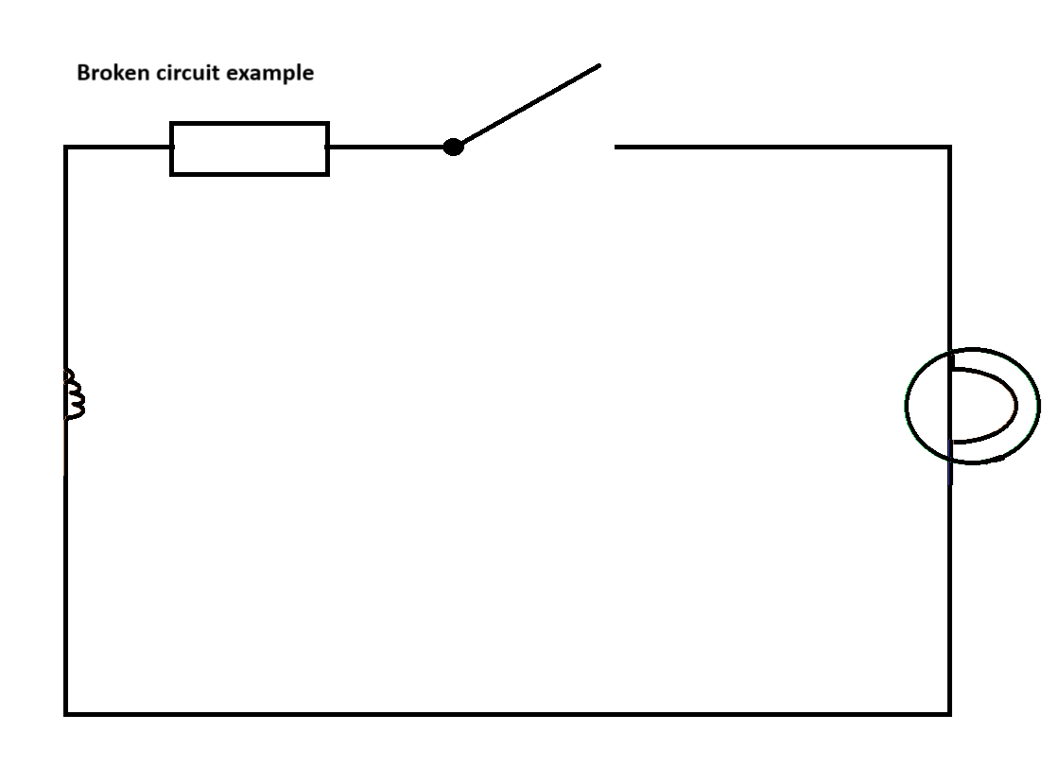

* For electricity to flow we need a complete circuit. In the above diagram the electricity will not flow.
* Electricity is magnetism which is moving through a cable.
* The flow (movement) of electricity is achieved through magnetic induction.

Electricity is the movement of electrons. Three effects of electricity are:

* **Heat (Thermal),**
* **Magnetism**,
* Chemical.

**Electricity in the domestic setting**

* Electricity causes heat,
* As electrons flow through a coil in the lightbulb which, in turn, causes light.

Everything in the domestic setting is based on the principle of **heat** and **magnetism** of electricity:

* Shower **heats up** water;
* Kettle **heats up** water;
* The Hoover motor uses **magnetism**.

**A comprehension of the Fuse**

* The fuse was designed to enable a short burst of over-current to assist with the start-up process;
* The first type of fuses were wires in between two terminals. The latter type of fuses are referred to as **BS 3036**.
* This is why in the on-site guide it states:

*“Where the protective device is a semi-enclosed fuse to BS 3036, Cf = 0.725 and for all other devices Cf = 1”*

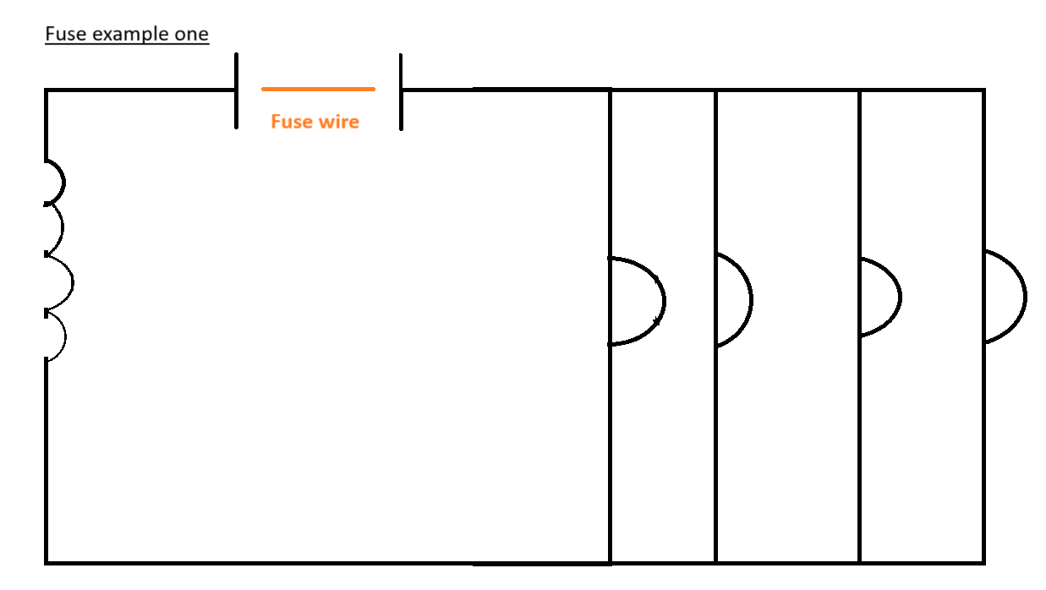

* The fuse wire would **melt/vaporise** if there was an overcurrent.
* The fuse wire was made of tin which had a lower boiling point.
* **5A fuse wire** is smaller than a **30 A fuse wire**
* **The disadvantage of the fuse wire is that it can be replaced with any type of wire. This creates rooms for error. Because previously kit-kat tin was used. However, it may not have the exact boiling point required.**

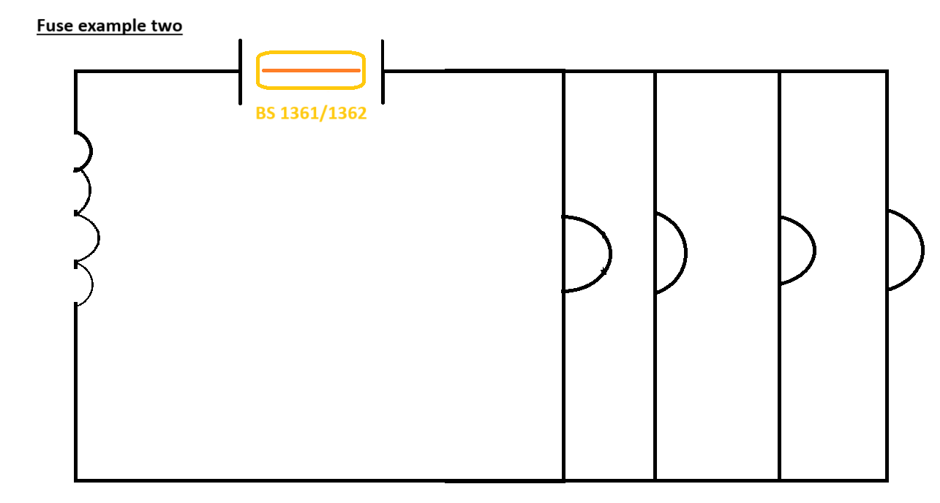

* Thermal means heat
* Upgrades were made to the previous iteration of the Fuse. One improvement was the placement of the fuse wire into a case. The benefit was that it provided protection to the end user. The fuse also contained Silicon (Sand) to assist with heat dissipation.

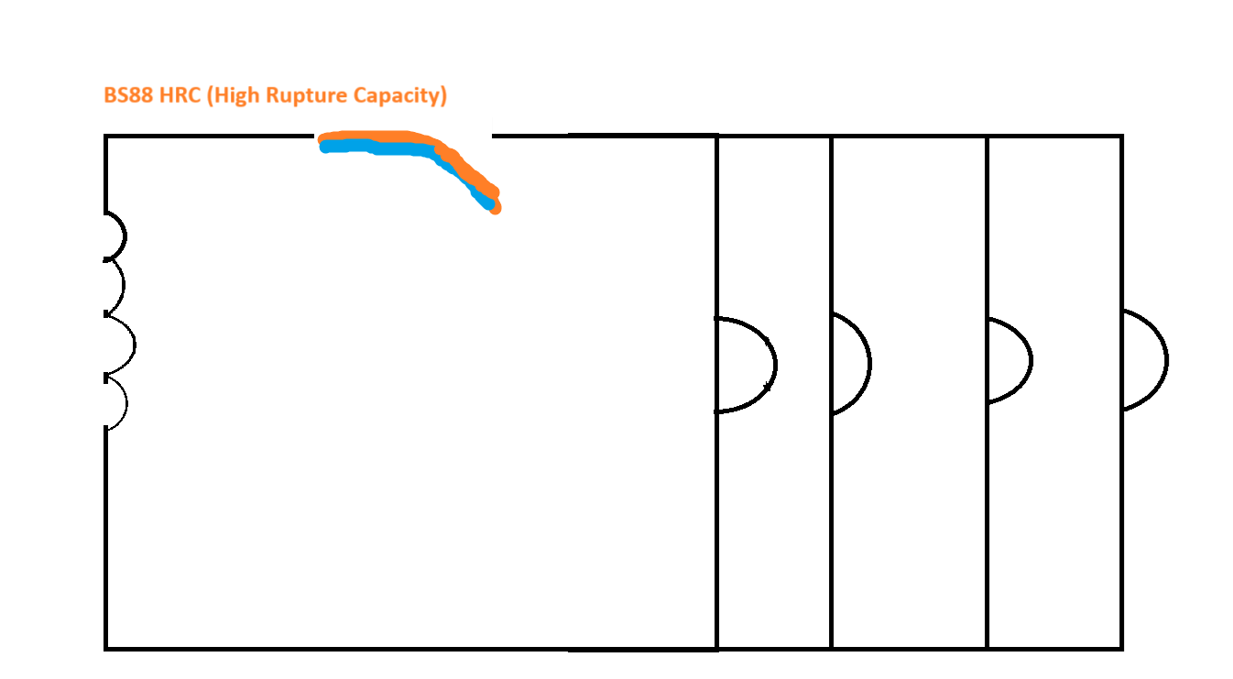

An engineer wanted to create a metal that would bend in the event of a fault.

The engineer wanted to use the effects of **thermal** and **magnetism**. One metal would have a lower boiling temperature than the other. **However, heat takes time**. **Heat is not instant**. However, **magnetism is**.

**A comprehension of fuse and circuit breaker**

The common factor between a fuse and a circuit breaker is the excess of current. The excess of current is what causes it to trip. Whether this is thermal or magnetic.

A **32 A breaker** will allow a current of up to **32 A.**

Current can only flow when there is a complete circuit.

There are two main cases where there will be excess current:

Different devices demand different amounts of current.

**Q: Why do we have different sizes of cables?**

Answer: Different cables have a different current carrying capacity.

**Case one:**

A fault in the circuit. To further expand the latter can be two situations;

* **Live** and **Neutral** and touch together
* **Live** and **CPC** touch together.

**Case two:**

Too many devices (overload) on a cable and demand current that the cable is not able to deliver for all the connected devices.

**Case One expansion**

**Live** and **Neutral** touch together

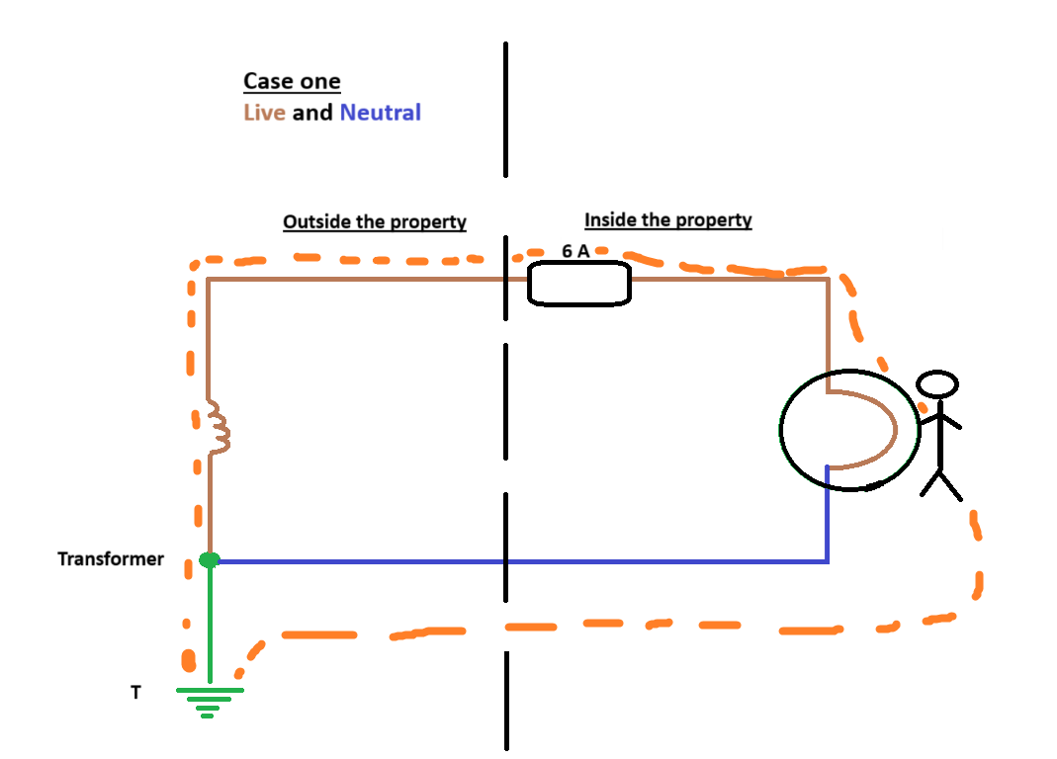

If the **Live** and **Neutral** touch together in a light switch case. Then there is a chance that the light switch case can become live (especially without the CPC). **This is called an Exposed electrical unit.** If Bob touches the light switch case then the electrical flow will enter into Bob and then make its way into the ground.

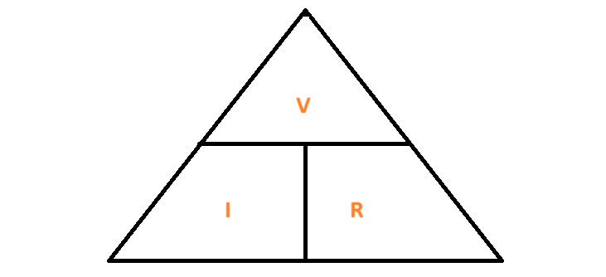

**The VIR formula triangle.**

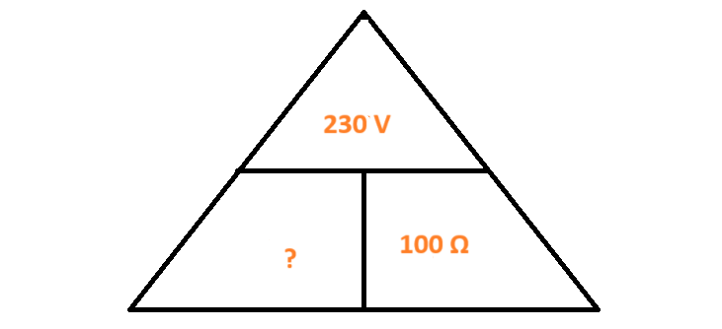

**VIR Calculations**

* 230 V (for a single phase system) / by 100 Ω = 2.3 Amps.
* 2.3 Amps is enough to fatally injure Bob.

**Case Two expansion**

**Live** and **CPC** touch together

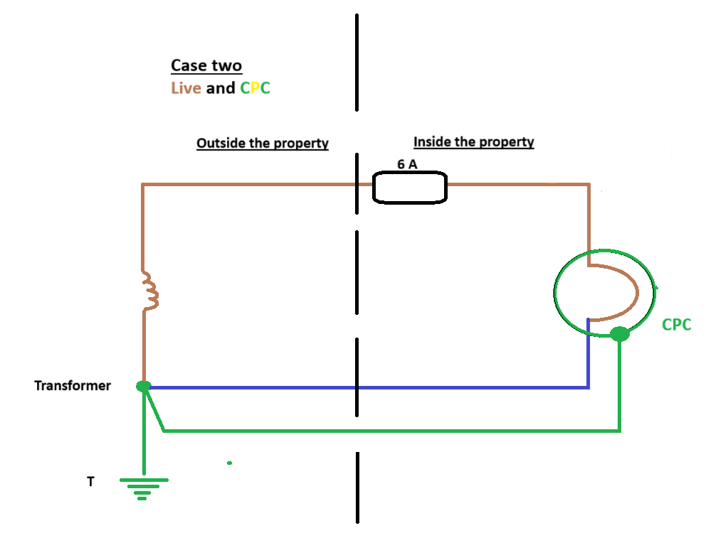

* Earth Fault Loop impedance
* When impedance is low, current is high
* Impedance is another word for resistance
* With this above picture we achieve ADS - Automatic Disconnection Supply.

**Three earthing systems**

**First depiction**

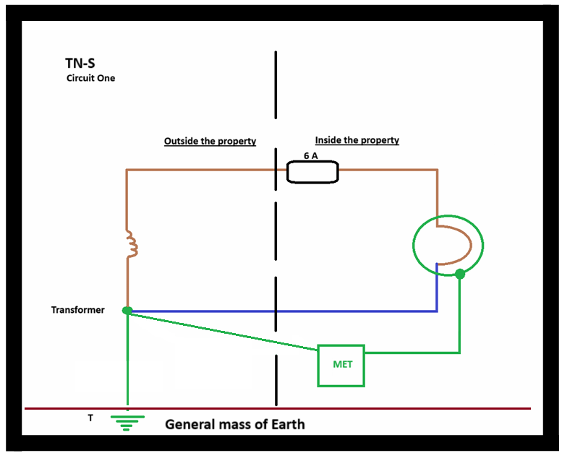

**Second depiction**

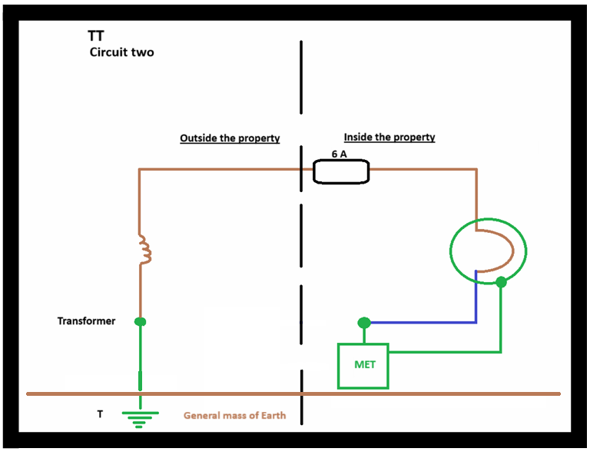

**Third depiction**

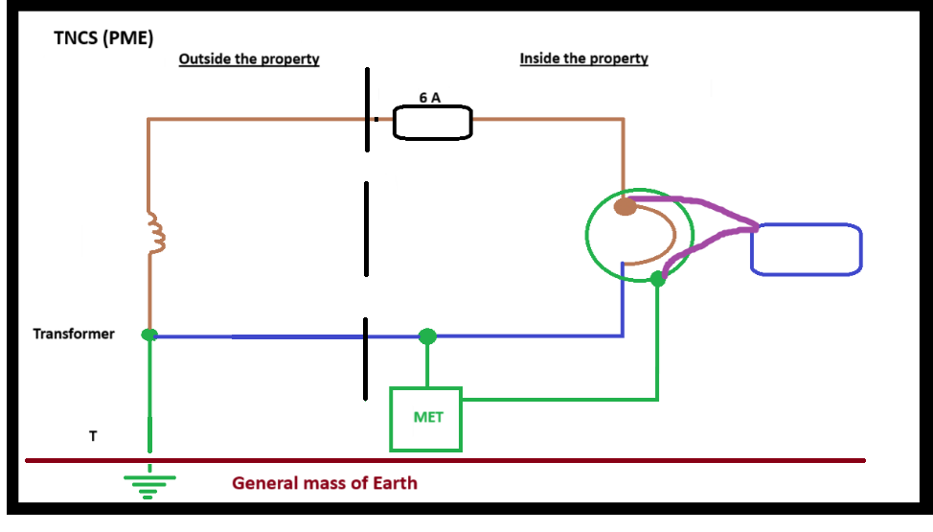

* **230 volts** enter into the dwelling.
* **218.5 volts** enters into dwelling once factors have been taken into consideration. This is because premises rarely receive the full amount due to the resistance in the cable. These factors are classified as Cmin.
* 30
* 218.5 Volts / 30 = 7.28 Ω
* 7.28Ω x 0.8 = 5.8
* (B type is 5 times, C type is 10 times and D type is 20 times)



**Earth loop fault impedance**

Earth Fault Impedance Loop => Zs

**R1** = Resistance of **cable one** which is **Live**;

**R2** = Resistance of **cable two** which is **CPC**.

**Earth loop fault impedance**

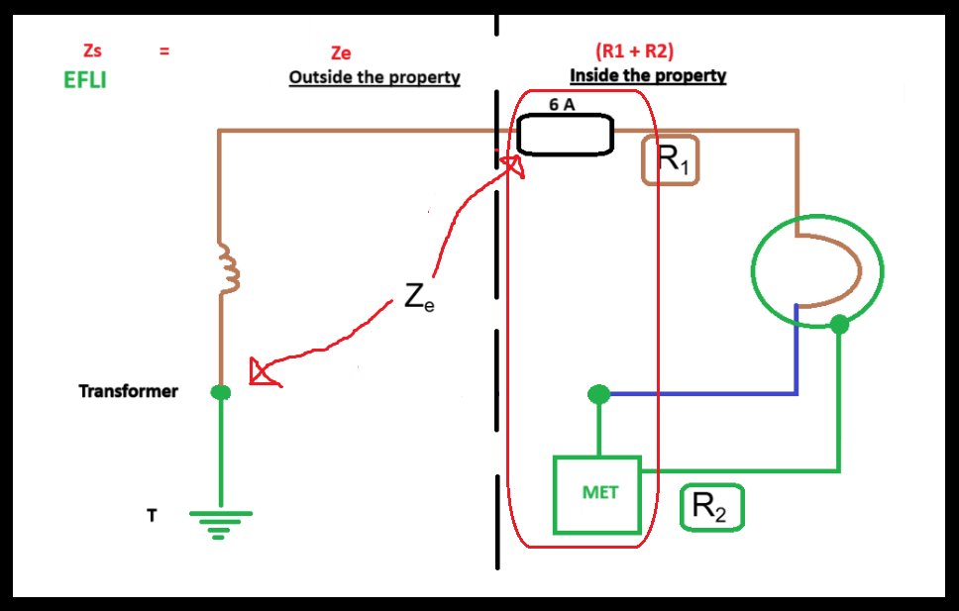

**Solenoid**

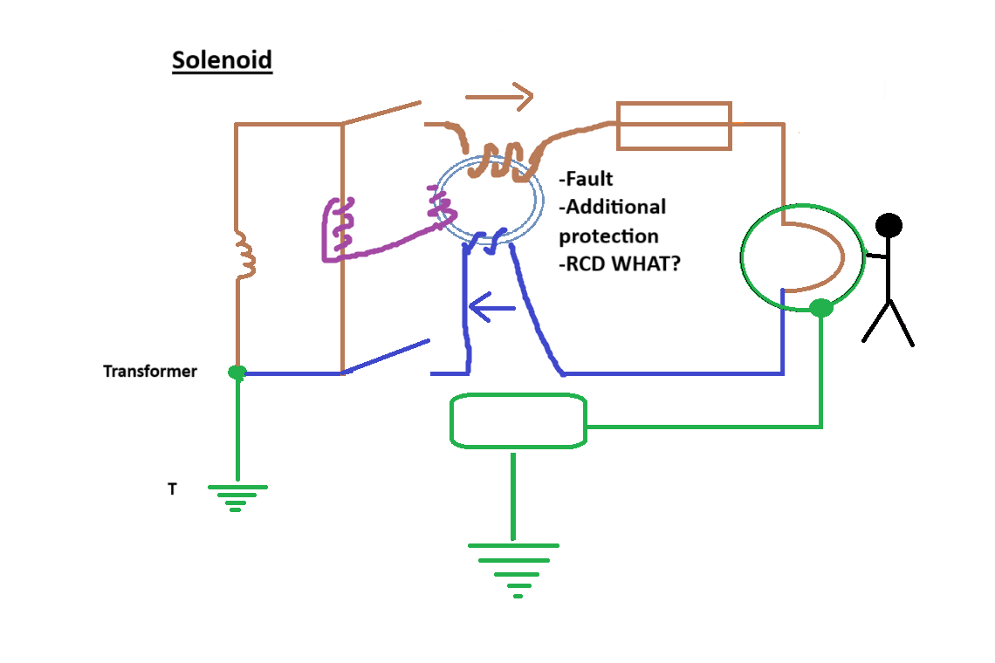

* It takes 0.03 Amps to trip a RCD.

**Calculation**



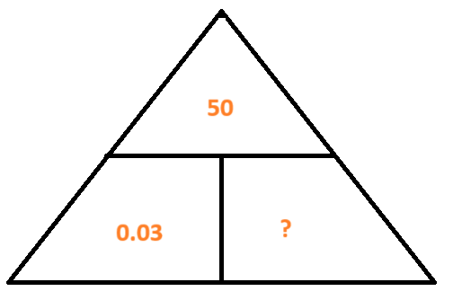

0.05 / 0.03 = 16.67 Ω

0.05 A + 50 Volts = person death

**Q: Why do we have different sizes of cables?**

**Answer**: Different cables have a different current carrying capacity.